FLS/POS Setup

Item Master

Configurator product

Pricing

VOL WGT

BOM/BOR

Simulator

Web entry

## Item Master

There needs to be an entry in the item master first before you copy the configurator item.

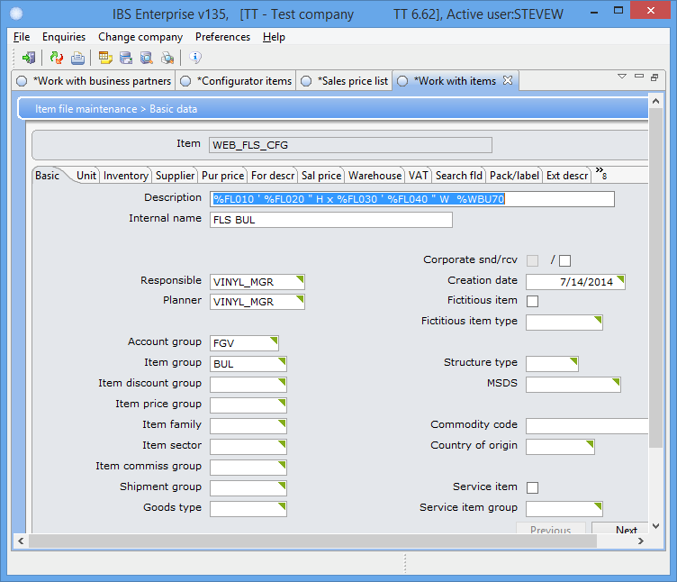

The Internal name is displayed on the web.

## Configurator product

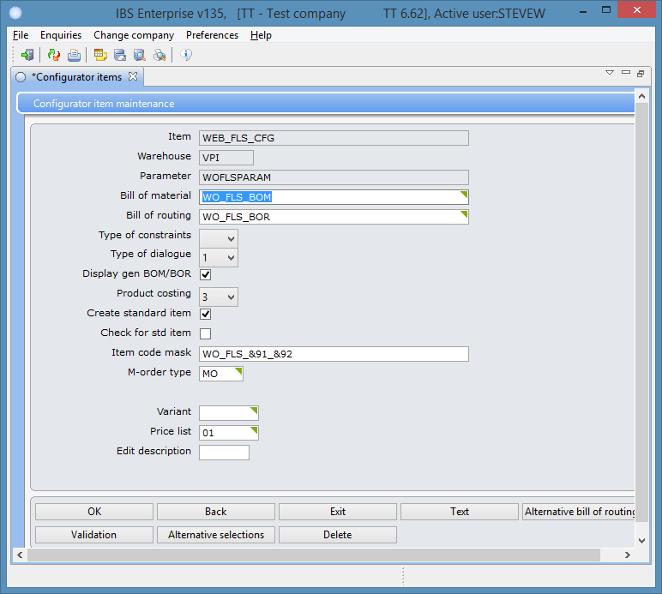

Uncheck the “Check for std item” it will not work with the web.

Parameter

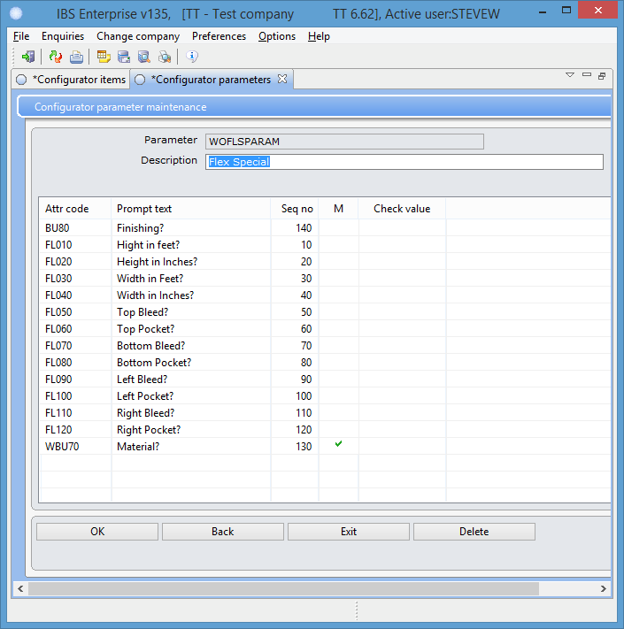

## Pricing

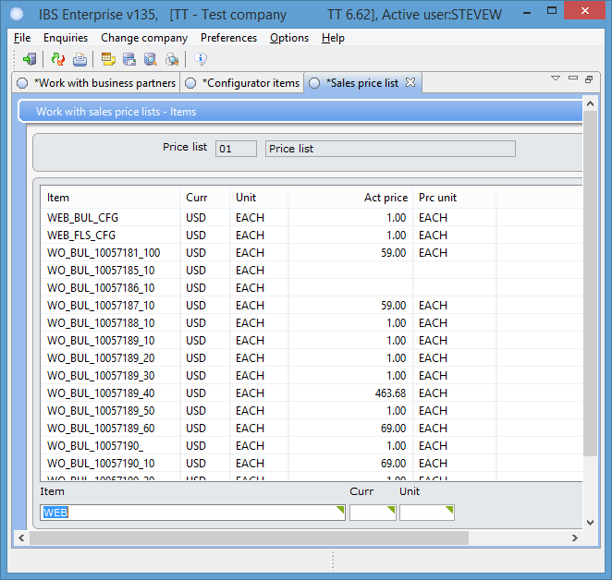

Add the new product to the correct price list.

## VOL WGT

All products must supply a formula that the web will use for the volume and the weight to get the Fedex charges.

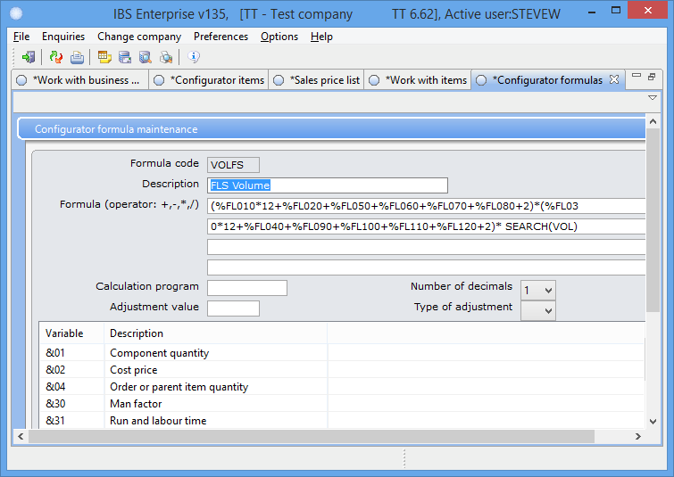

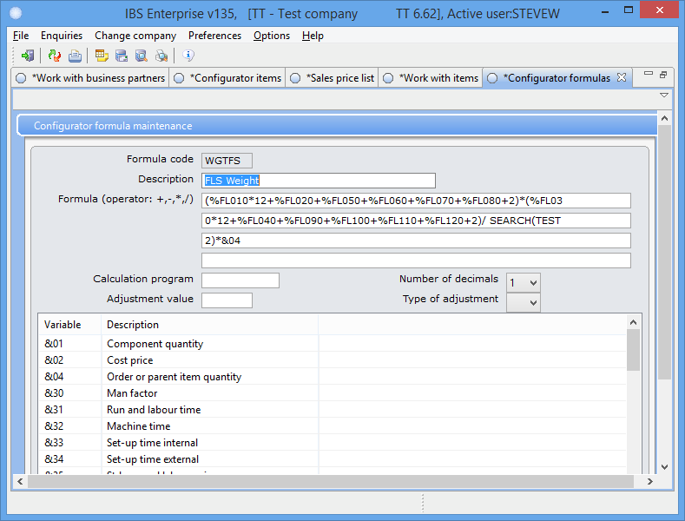

## BOM/BOR

Bill of material

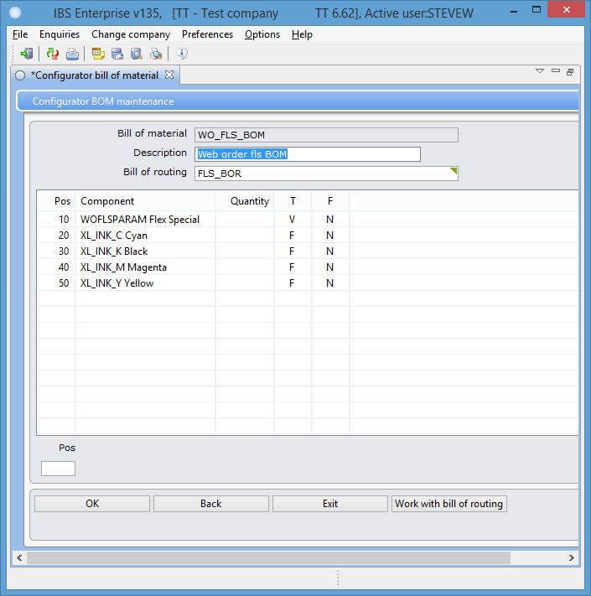

WBU70 Material EQ for item 10.

Bill of routing

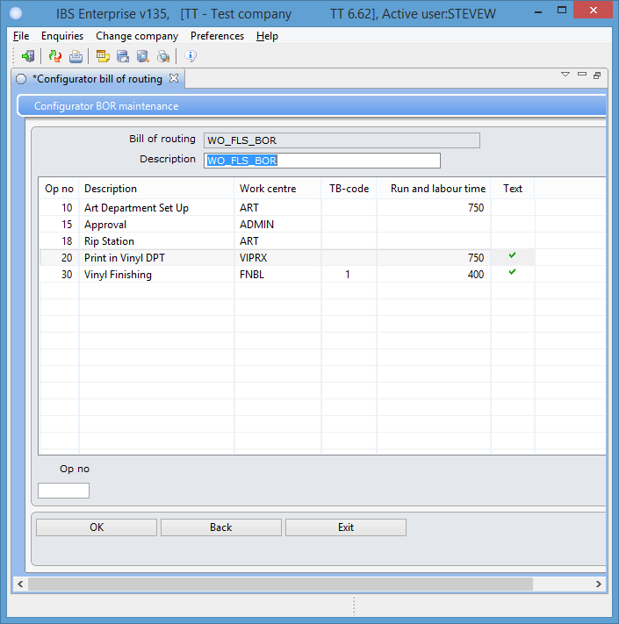

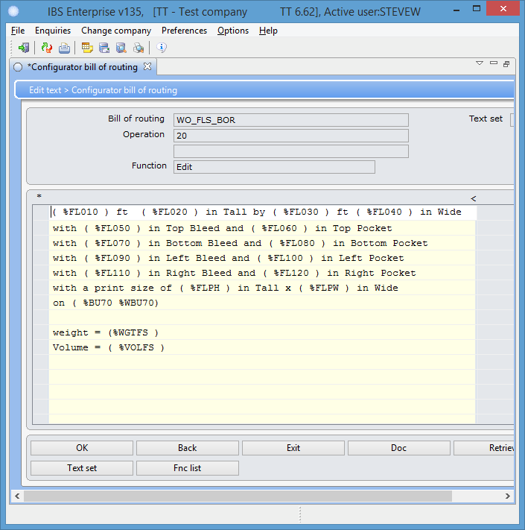Every product must use the text area it is used by the web to retrieve the correct formula to use for volume and weight.

## Simulator

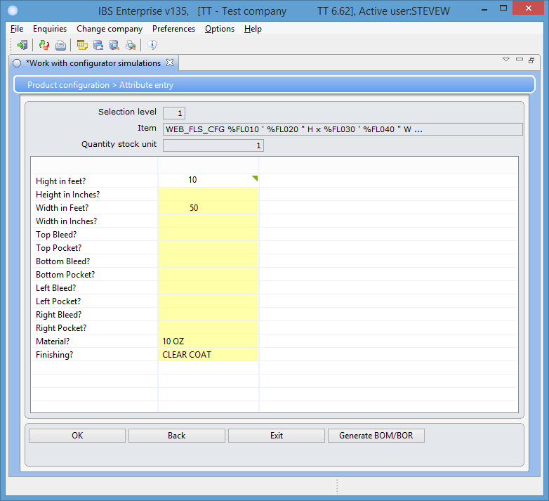

Bill of material

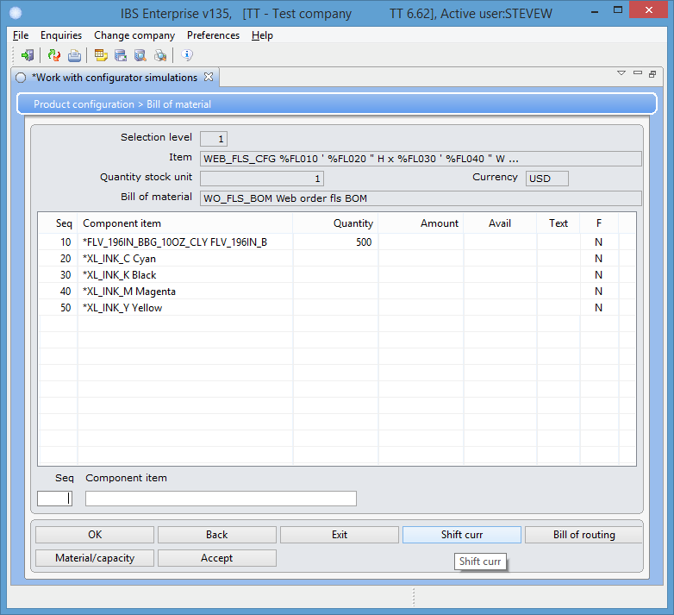

Bill of routing

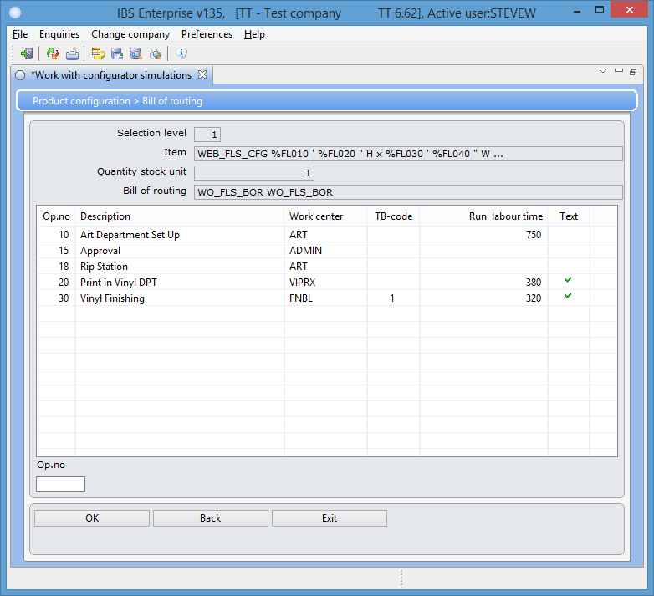

Item 20 text

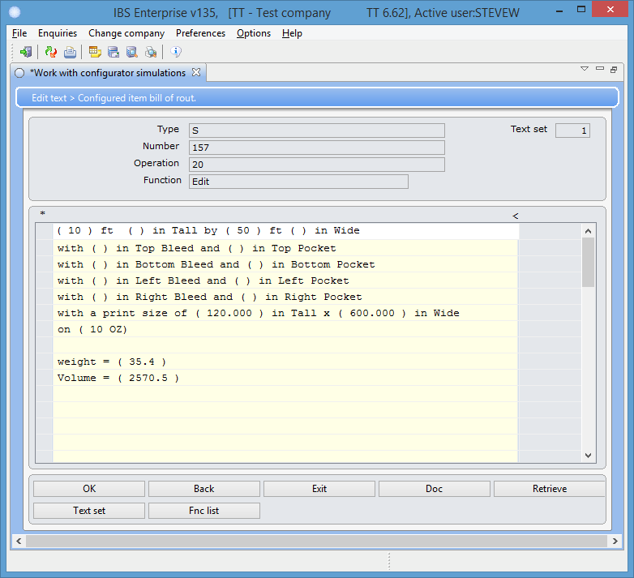

***You need to place the first order manually before you can use the web interface.***

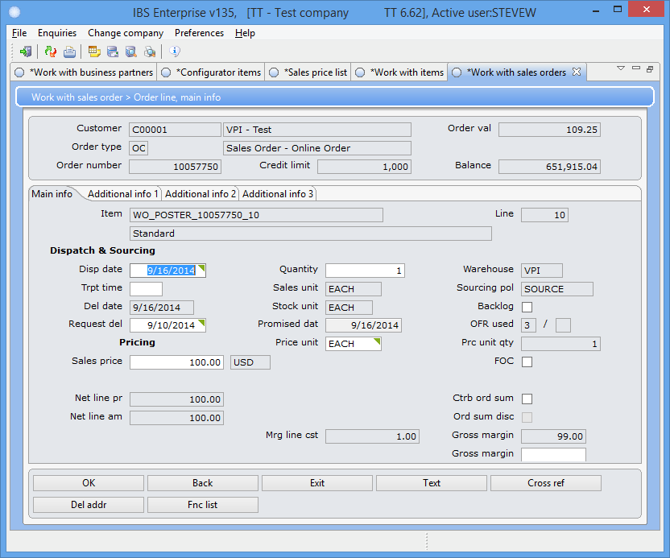

## Web entry

Once you have activated the product you should be able to place an order.

